Excel Extractor
This utility (app) looks at directory of consistent Excel files and consolidates that data from each Workbook into one table.

When Might I Use This?
You might use this app if you have a lot of Excel files that you want to extract specific data from. This could include:
- Consolidating a directory of completed budget templates from each department into one table.
- Extracting data from Excel-based expense claims or petty cash submissions into a table for Accounts Payable to process.
- Consolidating the monthly work-records from an entire office of consultants into one table that can be used for generating client's bills.

How To Use This App

Details of each step follows. As an overview, the steps you will take are:
- Create A Template File. Create an Excel file which maps the data you want to extract and how it will appear in the export table.
- Consolidate your source files. Put all of the files you want to consolidate into one directory.
- Run the app. Double-click on the ExcelConsolidator file (ExcelConsolidator.exe)
  - Select consolidated source files. Select the directory containing all of the Excel Files that you want to extract data from.
  - Select Template. Select the Template file you created in Step 1
  - Select an output filename. This will be an Excel file also.

1. Create A Template File
- A template file is an Excel file with 5 columns.
- When the app reads the template file, the first row is skipped because it might include the column headings.

Column Header | What you will include in this column
SourceSheet | The name of the worksheet that data will be extracted from. It is expected that each file in your Source File directory has this worksheet.
SourceReference | This is an Excel column and row reference. (A1, C27, AZ3). This is the data that you want to extract into a column into your consolidated Excel workbook.
OutputSheet | This is the name of the worksheet that the extracted data will appear in. In your Output File you can have multiple worksheets where the data is placed.
OutputColumn | This is the column number within the OutputSheet where the data you extract will be placed.  (Column 1 is number 1, Column 2 is 2, ect.)
OutputColumnName | You can provide a name to the column that you are extracting.

Note: If you define the same OutputSheet, OutputColumn, and OutputColumnName multiple times the app will select only one of your definitions.

2. Consolidate your source files
- Place all of your source files in a single directory.
- Every file in the directory should have the same layout of data. (The sheet-names should be the same, the location of the data will be the same, etc.)
- If the consolidator cannot find the data as defined by the Template File, it will not extract any data from the entire spreadsheet.

3. Run the App
To run the app, double-click on the ExcelConsolidator.exe file where you have saved it.

You may receive a Windows warning about the app. This is because there is no associated certificate with this app. Only run this app if you trust that this is a safe exe file.

Running the app will cause the following screen to appear.

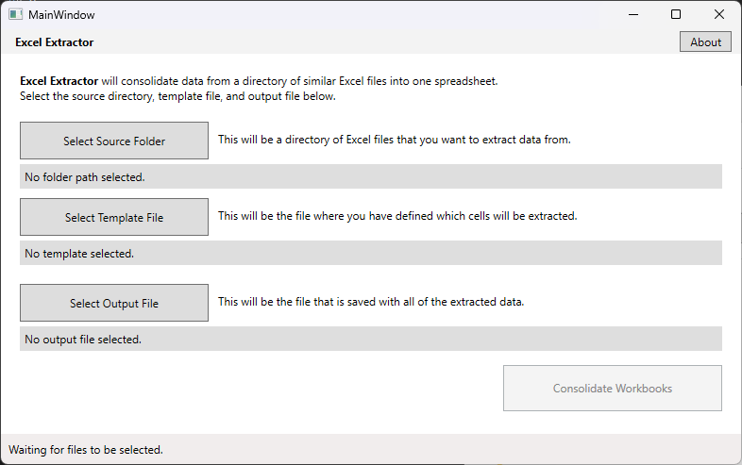
1
2
3
4
5
Below is an explanation for each number on the screenshot above.
  - Click this button to select the directory containing all of the Excel Files that you want to extract data from.
  - Click this button to select the Template file you have created and saved.
  - Click this button to select the name and location of the output workbook. This will be an Excel file.
  - You can see the status of the last action in this area. Once you have consolidated the data from your Excel workbooks, it will display a message here.
    - If the consolidation is successful, you will see the filename and directory where your file was saved.
    - If the consolidation fails, you will see an error message here.
  - Click this button to start consolidating the workbooks you have selected. You will not be able to click on this button until you have made a valid selection for numbers 1, 2 and 3.

Additional Notes

Some notes about how the app runs:
- The app only looks for modern Excel files in the source directory (.xlsx files.)
- If the app cannot find a specific cell in one of the source sheets, it will put a message into that cell. It is a long message, but it will give you the exact location of the cell that cannot be found. It will look like this:
Error: Sheet1!B17 not found in C:\SampleFiles\Directory Of Files\output_file.xlsx.
- If there is a file in your Source Directory that is corrupted, but still has an xlsx extension, the status message at the bottom your app will read:

